STEPS TO OPEN THE PROJECT THROGH THE DRIVE
Download the main folder inside the folder
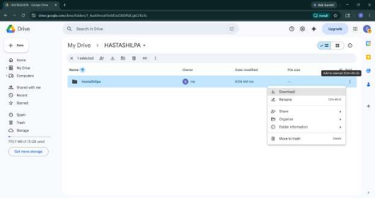You can see the downloaded zip file in this way on your downloads
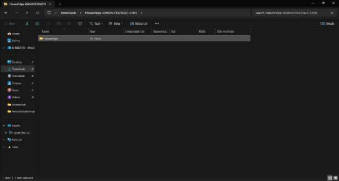
Open Android App studio
And click on OPEN & this window pops up
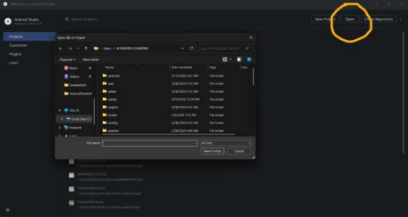If the folder isn’t available in the downloads section / Is your folder still a zip file then copy the main folder and paste it somewhere on the desktop
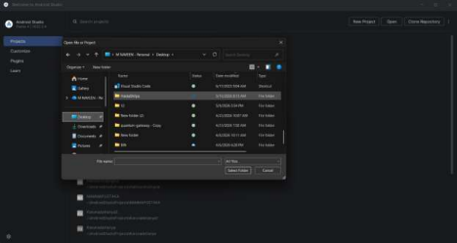
Click on the project folder and this window pops up & click on TRUST PROJECT 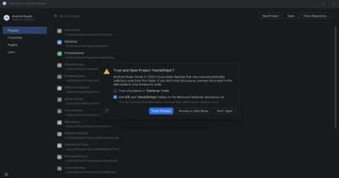This window pops up and wait till the gradle finishes (Usually take upto 3-5 min based on network speed and file size) the build
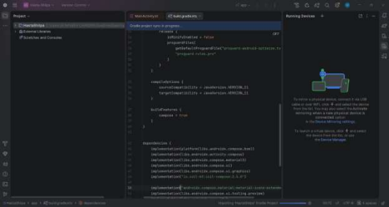
Later once the gradle building is finished this RUN button on the top will be activated and click on it
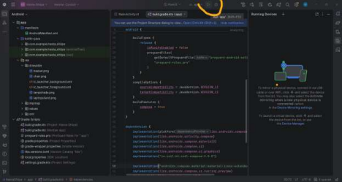
Once the installation is done the emulator window pops up with the respected project 